## horizontal line

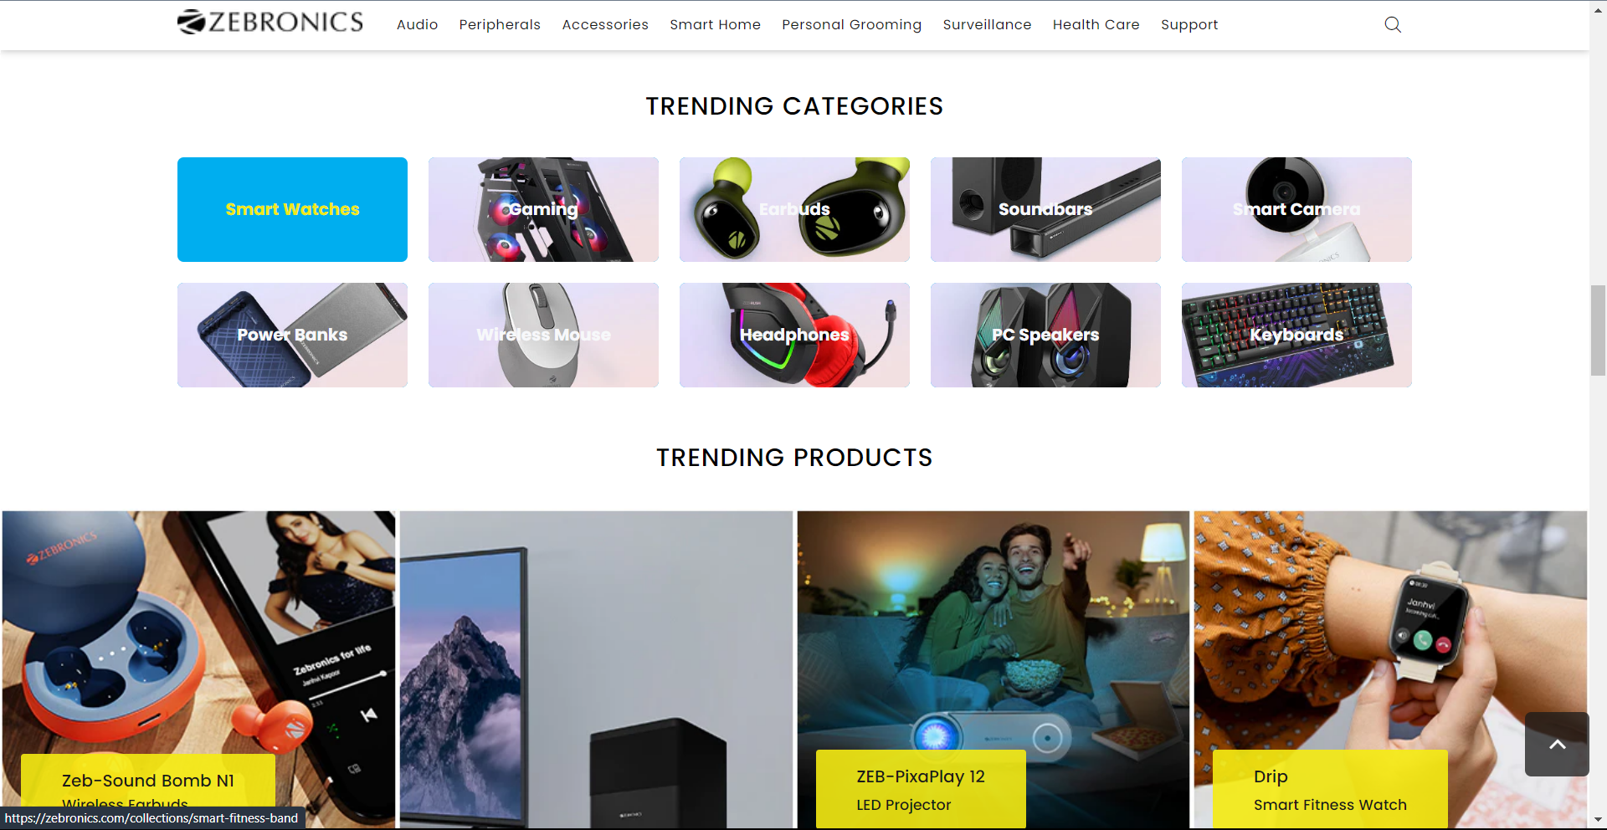

Zebronics

**─**

Khushil Ahuja

Edureka

# Overview

Zebronics is an e-commerce website for electronic gadgets, functional accessories, gaming gadgets and computer peripherals of their own brand.

# Goal

#HOMEPAGE

→Header

* Logo
* Quick icons/buttons
* Search bar

→Body

* Offers section
  + An image
* Trending gadgets
  + Slider image
* Video section
  + Branding Youtube videos
* Categories section
  + Categories of gadgets available
  + Images, text, next buy page
* Trending products
  + Images with responsive click
* Newly launched section
  + Product image, details and price
* Gadgets guide
  + Product viewing
  + Using and utilites of product

→Social Media

* Linking of social media/following
* Regular stuff update on social networks

→Page overview

* Joining of page, details paragraph, one click links

→Footer

* About us section
* Product section
* Help/support section
* Subscribe through (e-mail)

Copyright

Thankyou